# Lab 3 Report

## Team Information

**Lab number:** 3

**Date:** 10/29/2015

**Team Members:** Abigail Francis, Pierce Simpson, Brandon Lipjanic, Jonathan Hawkins

**Team Number/Name: PB&J (203)** Team Member Responsibilities

**Software Design:** Brandon Lipjanic

**Hardware Design:** Jonathan Hawkins

**Quality Assurance:** Pierce Simpson

**Systems Integrator:** Abigail Francis

**Wiki Creator:** Click here to enter text.

# Hardware

### Part 1

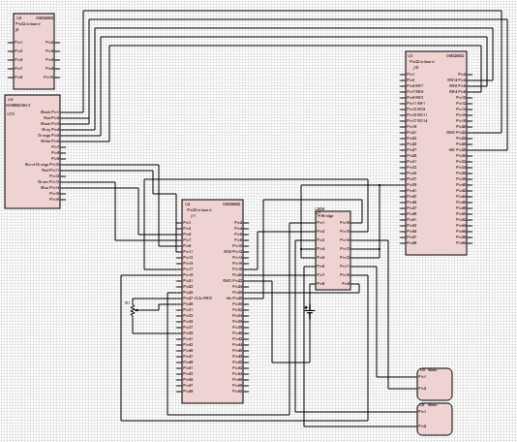

### Part 2

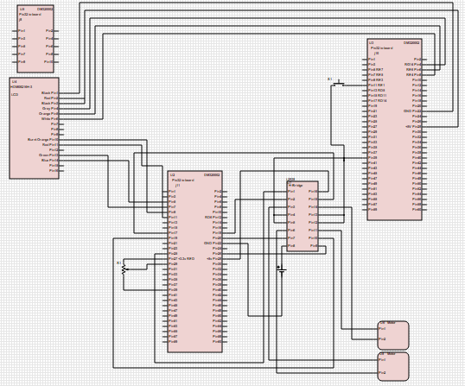

**Include a picture of any cables constructed for this lab.**

# Tests

### Part 1

|  |  |  |  |  |  |
| --- | --- | --- | --- | --- | --- |
| Test # | Test Name | Method | Software req'd | Detail | Tools req'd |
| P1-1 | Potentiometer functionality | Test the variable resistance of the potentiometer using DMM | N/A | Red probe to either outside pin on pot. Black probe to middle pin on pot. | DMM  2x probes |
| P1-2 | Test H-bridge and motors | Hook up H-bridge Vs and VSS to DC power supply. Hook up function generator inputs to inputs H-bridge. Hook up motors to H-bridge. | N/A | Motors: | DC supply  Function generator  4x alligator clips |
| Hook up red cable of motor to +5V on DC power supply. Hook up black cable of motor to GND.  H-bridge:  Hook up VS and VSS to 5V on DC power supply. Hook up function generator to inputs 1-4 on H-bridge with pulse wave of 25% duty cycle and 3.3V amplitude. Hook up motors to outputs 1-4 on H-bridge. Hook up GND on H-bridge to GND. Adjust duty cycle on function generator to increase motor speed.  Scope the 2 of the output pins to check pulse is coming through. | Male to male jumpers |
| P1-3 | Test output-compare modules | Hook oscilloscope up to output compare pins on expansion board and test duty cycle. |  | Hook up oscilloscope red probe to RD1, pin 20 on J11; hook up black probe to RD0, pin 19 on J11. Power on robot and check waveform. | Oscilloscope  1x Probe |
| P1-4 | Check speed control of motors with software function |  | See test.c included with code. |  | My fingers |
| P2-1 | Test all connections | Use DMM to test all connections |  | Test each pin with red probe and black probe to ground. | DMM  2x probes |

See detail column on table above for how each test was performed.

Test P1-1

Outcome shows that potentiometer was sweeping between 1k and low resistance when knob was turned. Test passed.

Test P1-2

Figure 1

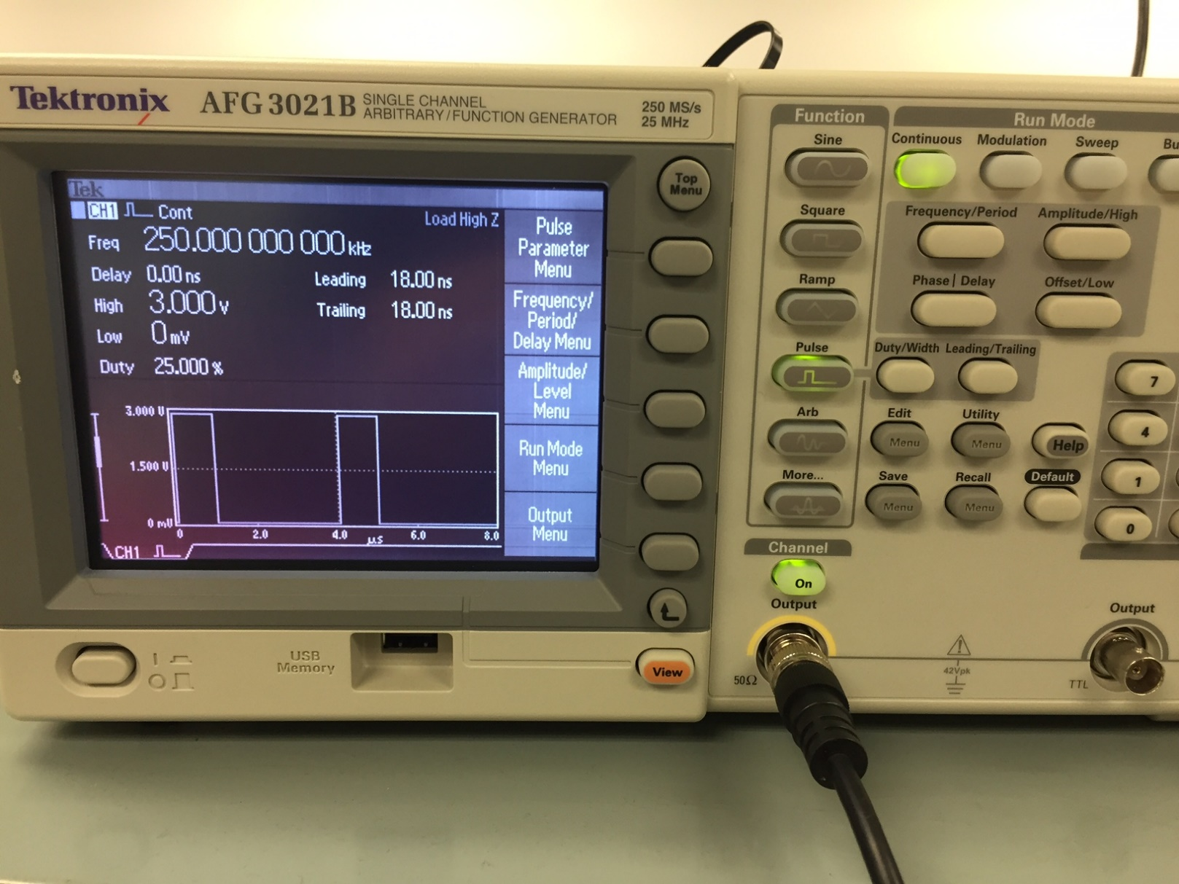

Figure 1 shows the PWM being generated by the pulse generator. It was initialized to 3V with a duty cycle of 25%.

Figure 2

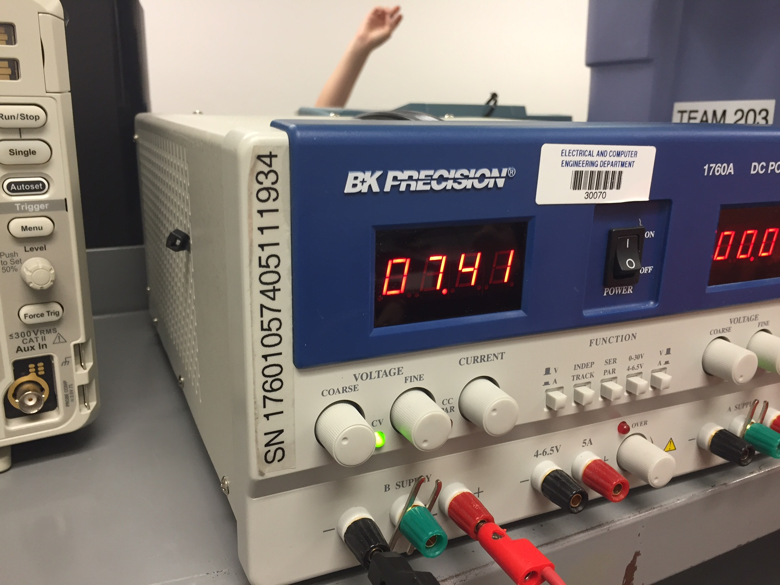

Figure 2 shows the voltage fed to the H-bridge.

Figure 3

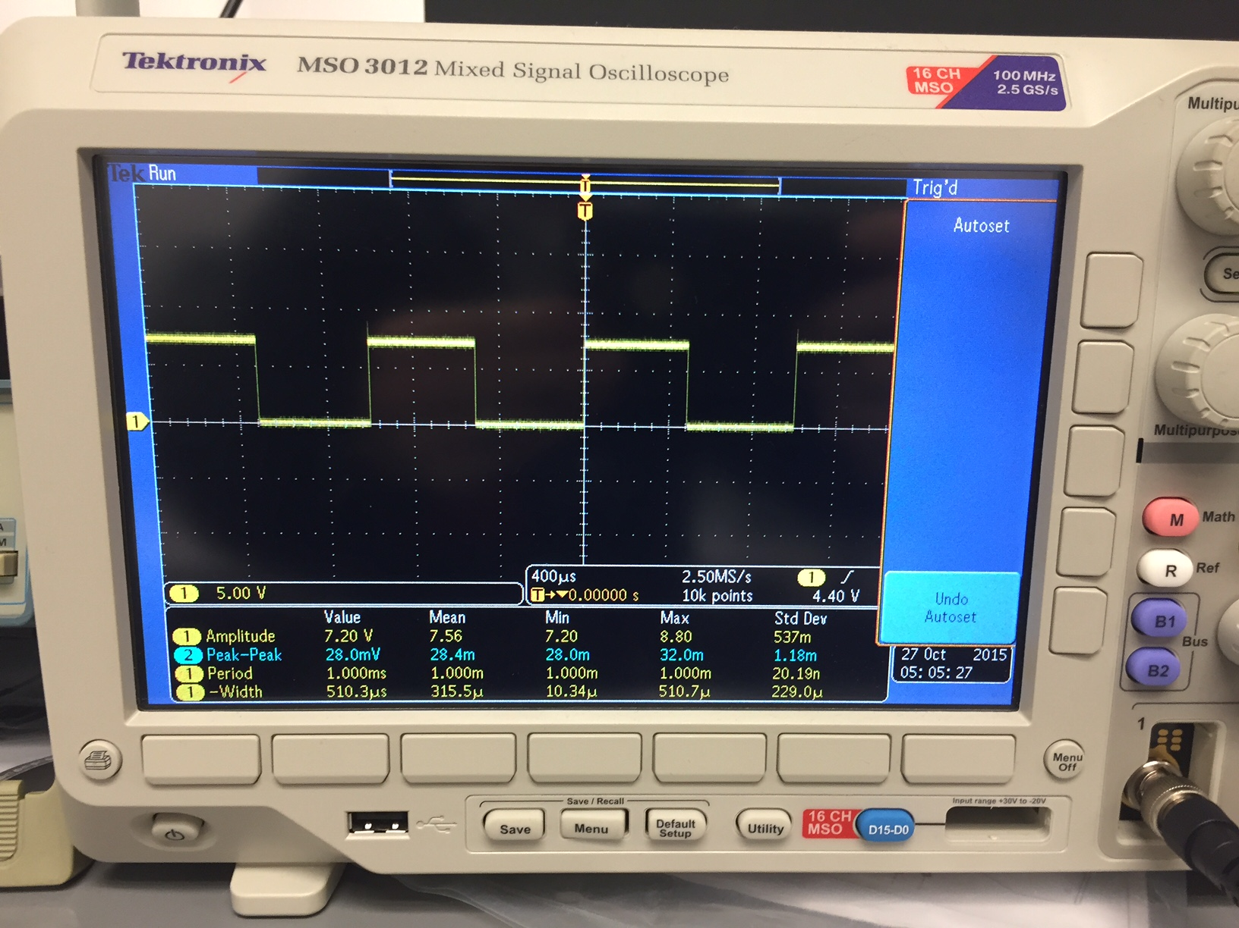

Figure 3 shows the output of the PWM signal as read from two output pins on the H-bridge. This shows a PWM of 50% because we were testing the motor speed by adjusting the duty cycle on the function generator.

Figure 4

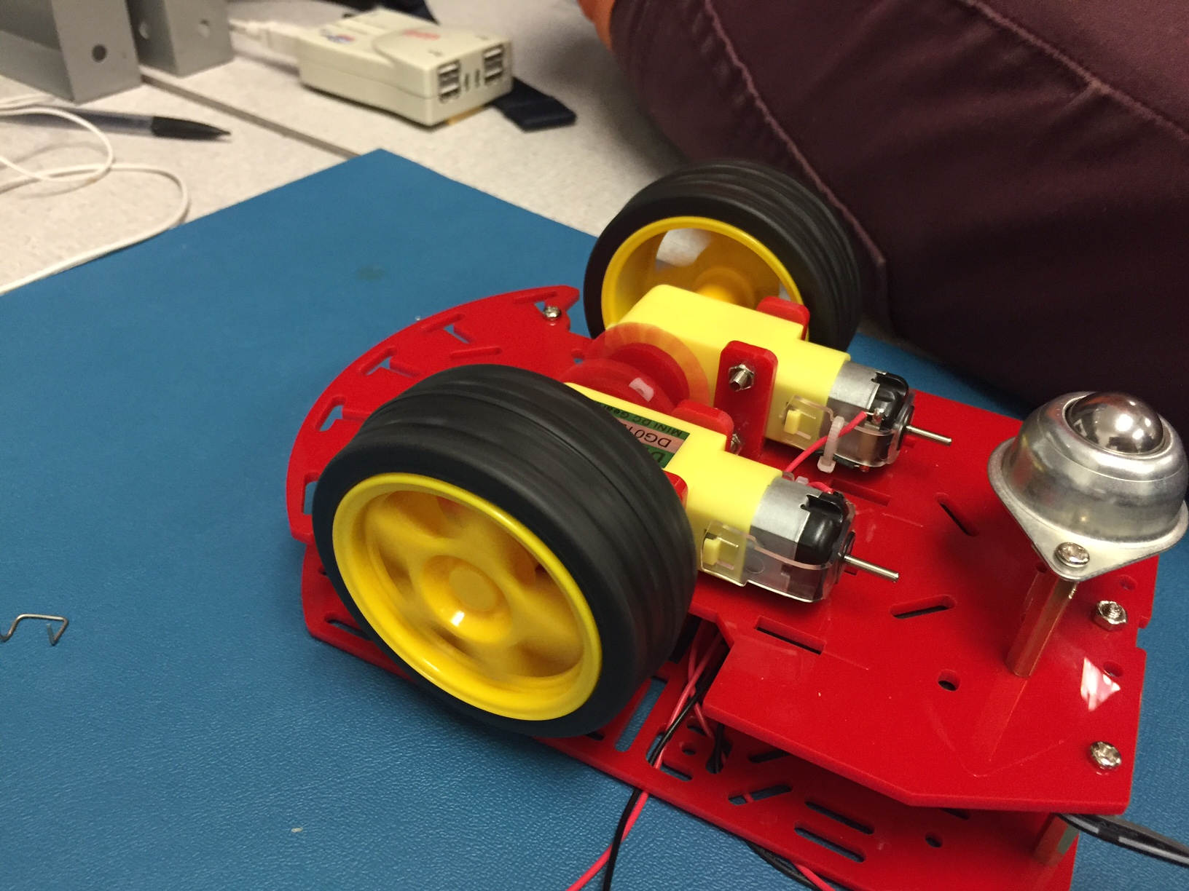

Figure 4 shows the wheels in action.

After making all connections, we were able to make sure the H-bridge was working correctly by adjusting the duty cycle on the function generator. This resulted in proportional speed adjustment in the motors. We were also able to adjust the speed of the motors by adjusting the voltage on the DC power supply. Test passed.

Test P1-3

Figure 5

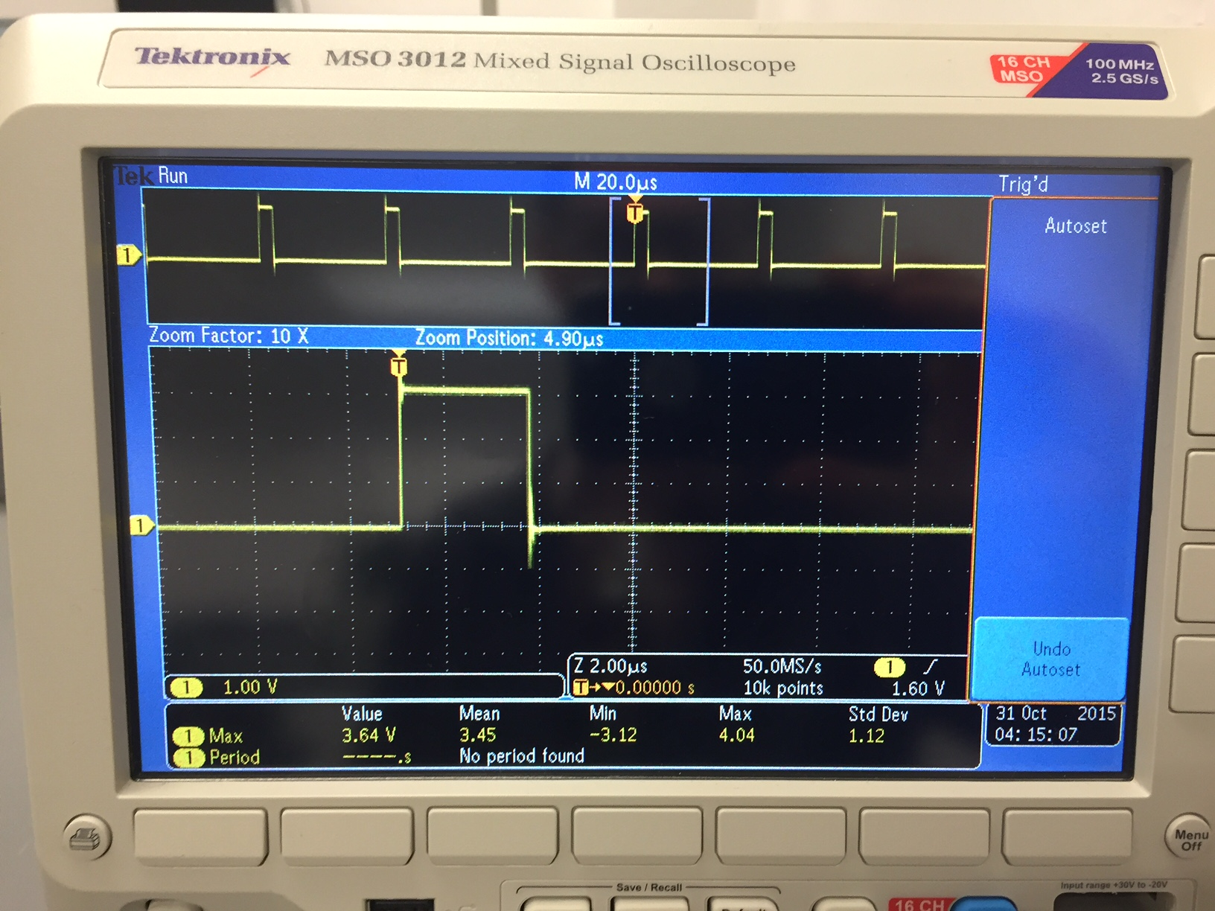

PWM seen on RD0 and RD1 of expansion board.

Figure 6

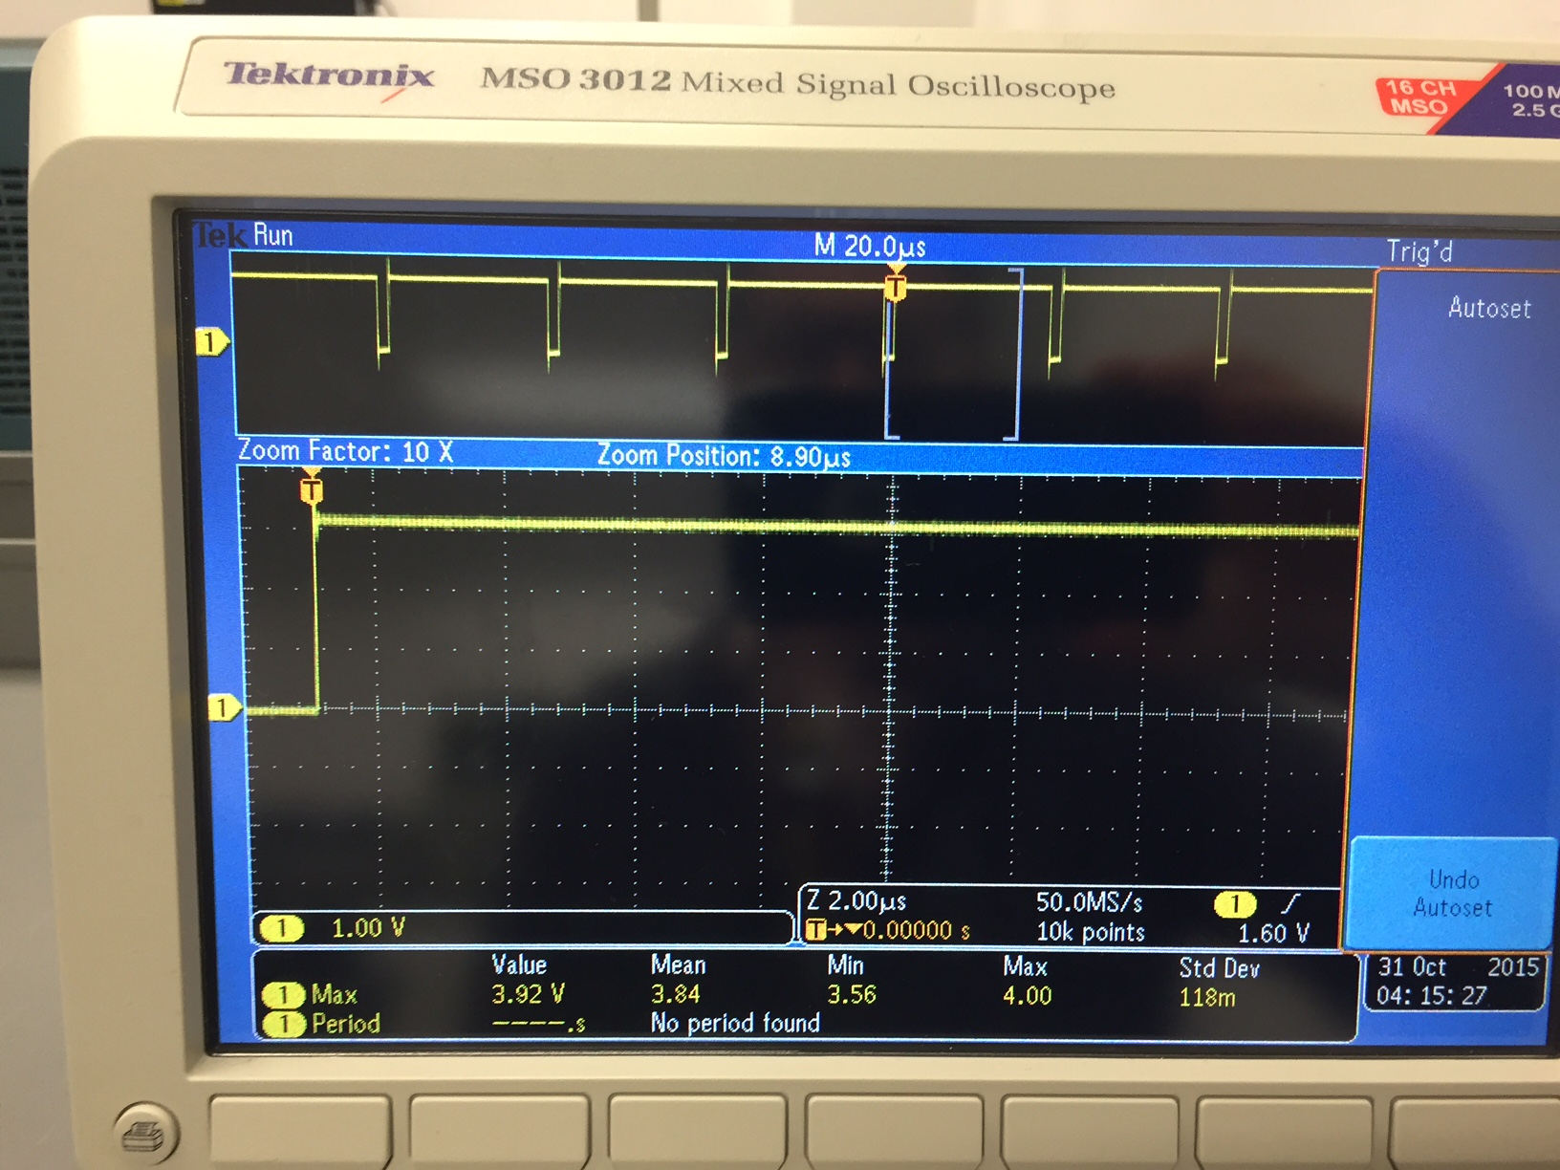

Increased pulse width as seen on same pins. This was achieved by adjusting the potentiometer.

Outcome shows a distinct pulse. When the potentiometer was adjusted from left to right, the duty cycle increased and the pulse became wider. When the potentiometer was adjusted all the way left, noise was shown because this disabled the right wheel. Test passed.

Test P1-4

We wrote a software test function (test.c included with code) that used loops to adjust the ADC values passed into our setMotorsSweepForward() and setMotorsSweepBackward() functions. The result showed the right motor successively increase in speed until full speed and then the left motor successively decreased in speed until it stopped. This function also checked the gradual increase of the left motor speed and the decrease of the right motor speed. This was performed for both forward and backward motions. Test passed.

### Test P2-1

### All connections working based on DMM tests. This is also confirmed by the robot functioning correctly.

Figure 7

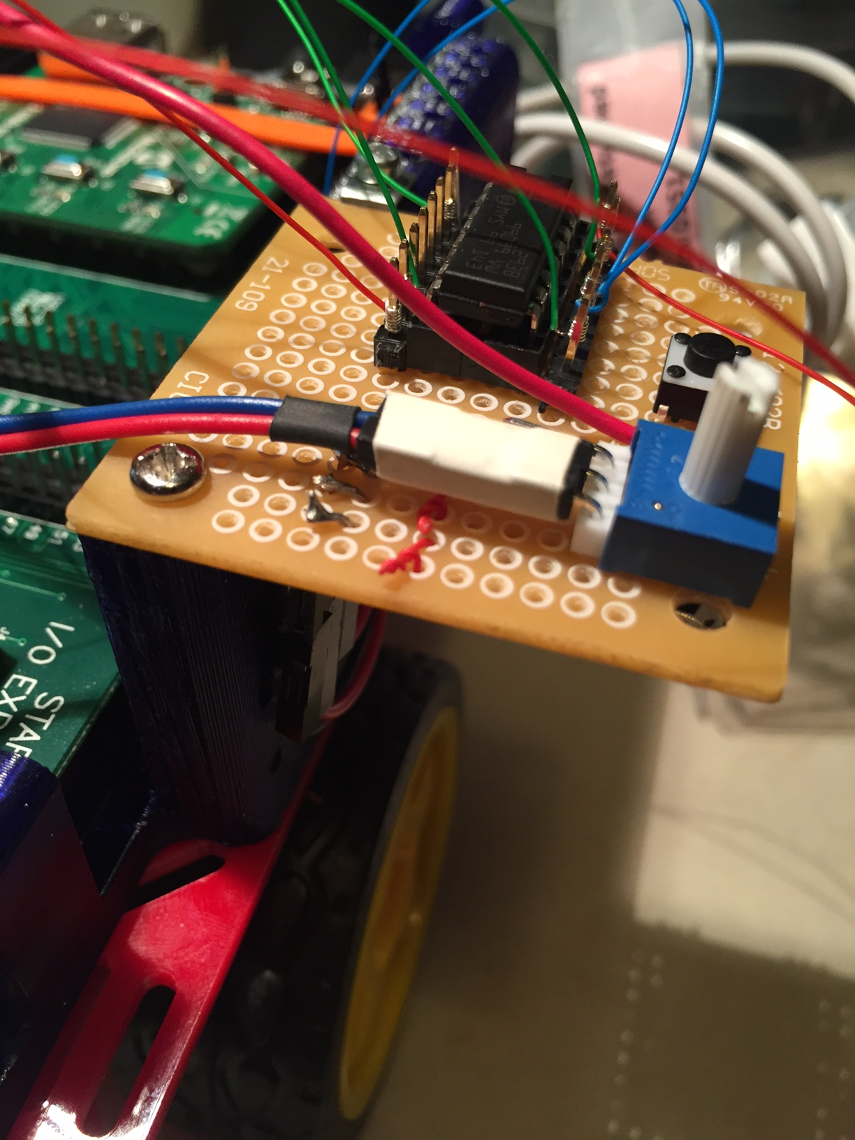

Custom connector to potentiometer

Figure 8

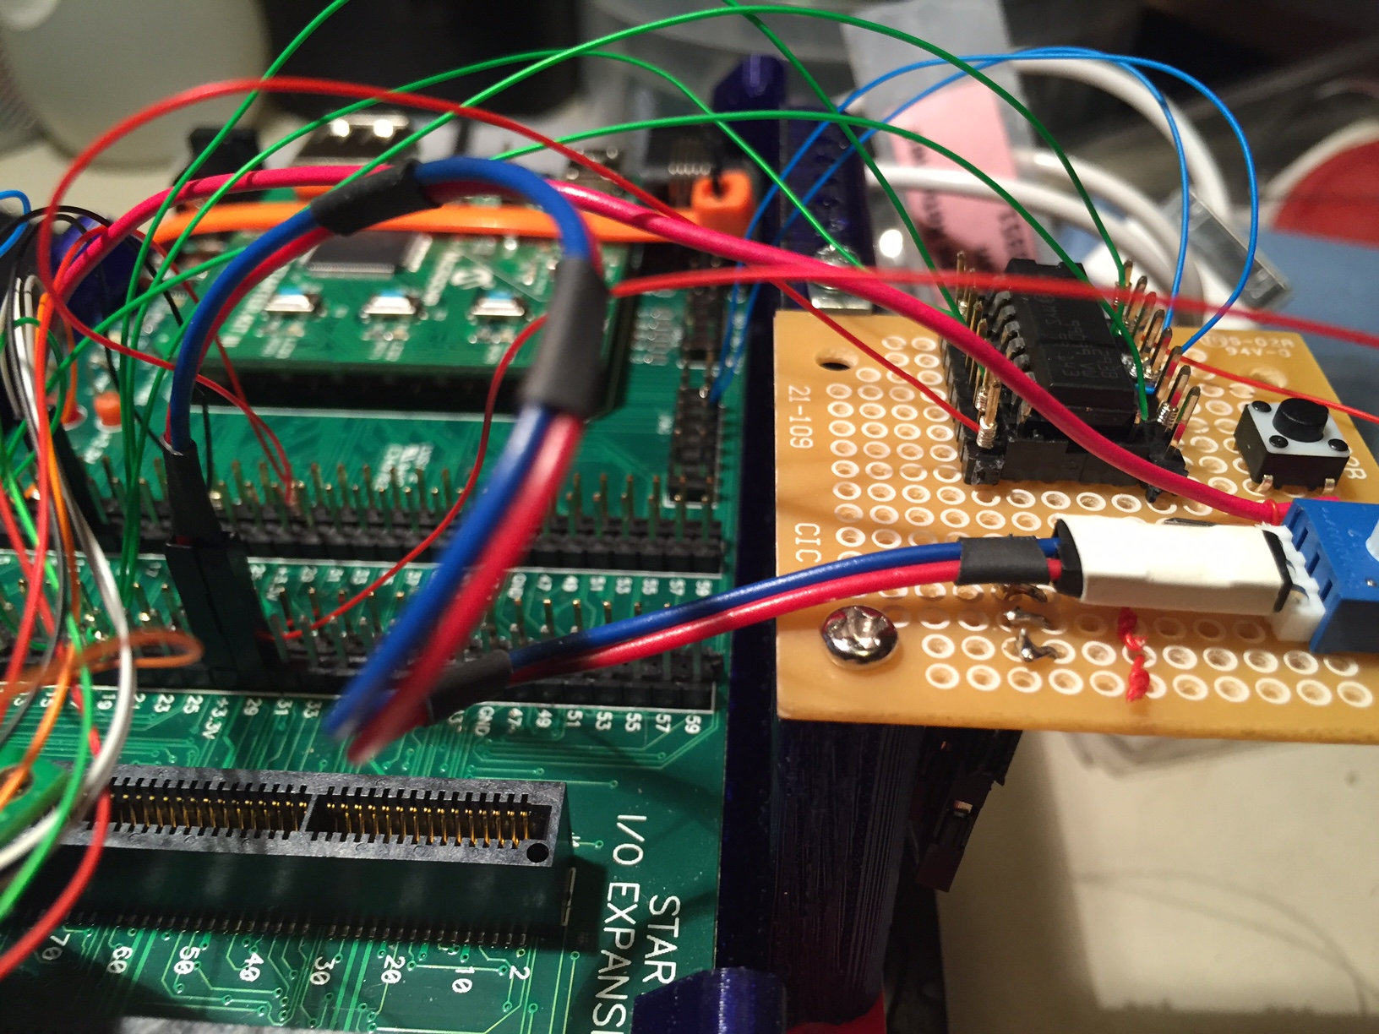

Another view of custom connector

Figure 9

### C:\Users\SimpsPR\AppData\Local\Microsoft\Windows\INetCache\Content.Word\IMG_2118.jpg

Wire wrapping to expansion board. Note molex connectors on J11 are termination of custom cable.

Figure 10

### C:\Users\SimpsPR\AppData\Local\Temp\Rar$DR57.992\IMG_2119.JPG

Wire wrapping to H-bridge